What is OOP?
OOP (Object-Oriented Programming) is a modular software design approach used in almost every enterprise-level application — whether it’s a banking system, e-commerce platform, or HR management system.
It allows us to:
- Model real-world entities (like employees, customers, or invoices)
- Organize large projects into manageable, reusable, and testable components
- Maintain cleaner and scalable codebases
4 Core Principles of OOP
Concept | Definition | Real-World Example
Encapsulation | Keeping data and methods that operate on that data within one unit (class). | In a User class, private password is hidden, and only getPassword() or setPassword() can access it.
Inheritance | Reusing code by deriving new classes from existing ones. | Manager class inherits from Employee class.
Polymorphism | The same method can behave differently based on context. | generateReport() behaves differently for HR and Finance modules.
Abstraction | Hiding complex implementation details and showing only necessary features. | Developers use a PaymentGateway interface without knowing whether the implementation is Stripe or Razorpay.

Class in Java
👉 Definition:
A class is a blueprint for creating objects. It defines data (fields) and behaviors (methods).
In a real project, you’ll have classes like:
- Employee, Customer, Product, Invoice, DatabaseConnector, APIService, etc.

Example (Real IT Project)
📦 Example 1: Employee Management System
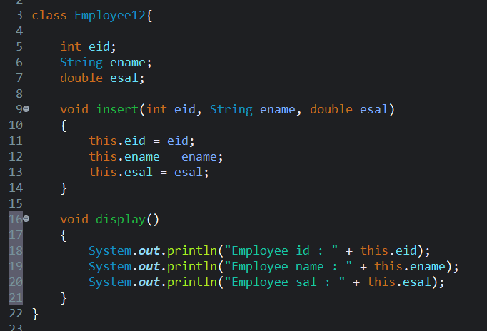
Object in Java
👉 Definition:
An object is a real instance of a class.
It occupies memory and represents an actual entity in your software system.
In industry, each record in a database (e.g., each employee in the table) is often represented as an object in code.
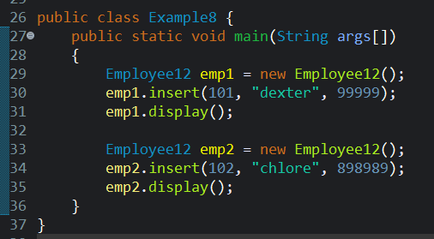
Example:

Methods in Java
👉 Definition:
A method defines the behavior of an object — i.e., what that object can “do”.
In enterprise applications, methods represent business logic — such as:
- calculateTax()
- generateInvoice()
- processPayment()
- validateLogin()
- sendEmailNotification()
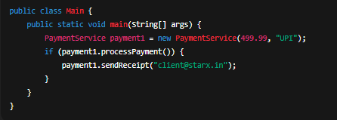
Example 2: Payment Processing System
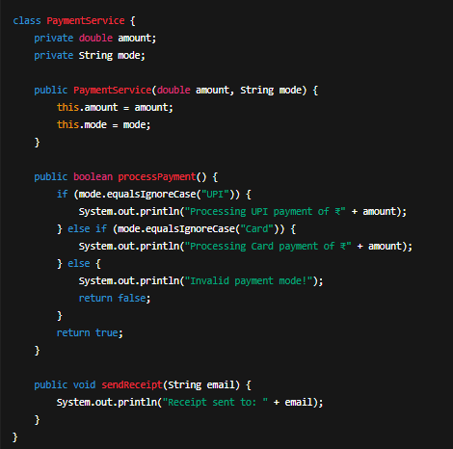
What is a Method in depth?
A method in Java is a block of code that performs a specific task.
It helps reuse code, organize logic, and make programs modular and readable.
In simple terms:
👉 A method = function + belongs to a class.

Syntax of a Method :
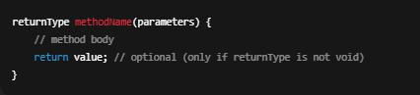
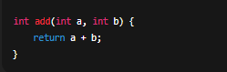
Example:
Here:
- int → return type
- add → method name
- (int a, int b) → parameters
- return a + b; → statement that sends back the result

Types of Methods in Java
Type | Description | Example
Predefined methods | Already defined in Java libraries | System.out.println(), Math.max()
User-defined methods | Created by the programmer | calculateBonus(), getEmployeeDetails()
Static methods | Belong to the class, not to objects | main()
Instance methods | Belong to objects; need object creation | emp.calculateBonus()

Parameters vs Arguments
Term | Meaning | Example
Parameters | Variables listed inside method definition | void greet(String name) → here name is a parameter
Arguments | Actual values passed when calling the method | greet("Rohan") → here "Rohan" is an argument
Think of it like:
Parameters = variables in the method
Arguments = actual values you pass to it

Method Signature
A method signature includes:
- Method name
- Parameter list (number, type, and order of parameters)
Example:

This means add(int, int) is the signature.

Why Methods are Important (Industry Use)
- Organize business logic cleanly
- Avoid code duplication
- Improve readability and testing
- Make collaboration easier in large teams
- Used in backend logic, APIs, and microservices every day

Example 1: Greeting Method
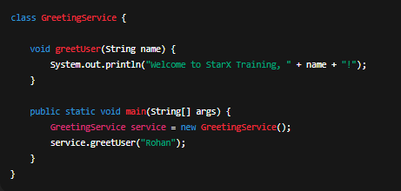
Explanation:
- Method name: greetUser
- Parameter: String name
- Argument passed: "Rohan"
Output:

Example 2: Salary Calculation
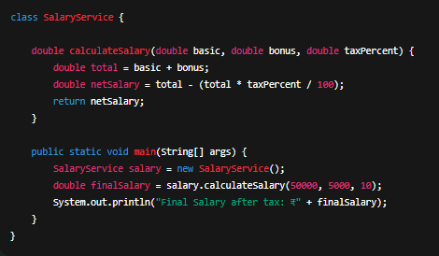
Explanation:
- 3 parameters → basic, bonus, taxPercent
- Returns a value of type double
- Used in HR/payroll systems in real projects
Output:


